**Face Recognition System**

**Step – 0: Install Required library**

* **pip install Pillow**
* **pip install opencv-python**
* **pip install tk**
* **pip install mysql-connector-python**
* **pip install os-sys**
* **pip install numpy**

**MySQL**

**CREATE database face_recognition;**

* **Create table Student_info( Departmenat Varchar(50),Course Varchar(50),**

**Year Varchar(50),**

**Semester Varchar(50),**

**Id int(20) PRIMARY KEY,**

**Name Varchar(50),**

**Division Varchar(50),**

**Roll_no int(25),**

**Gender Varchar(50),**

**DOB Varchar(50),**

**Email Varchar(50),**

**Phone Varchar(50),**

**Address Varchar(50),**

**Teacher Varchar(50),**

**Photo Varchar(50)**

**);**

**Step: 1 – Run (main.py) Main Window**

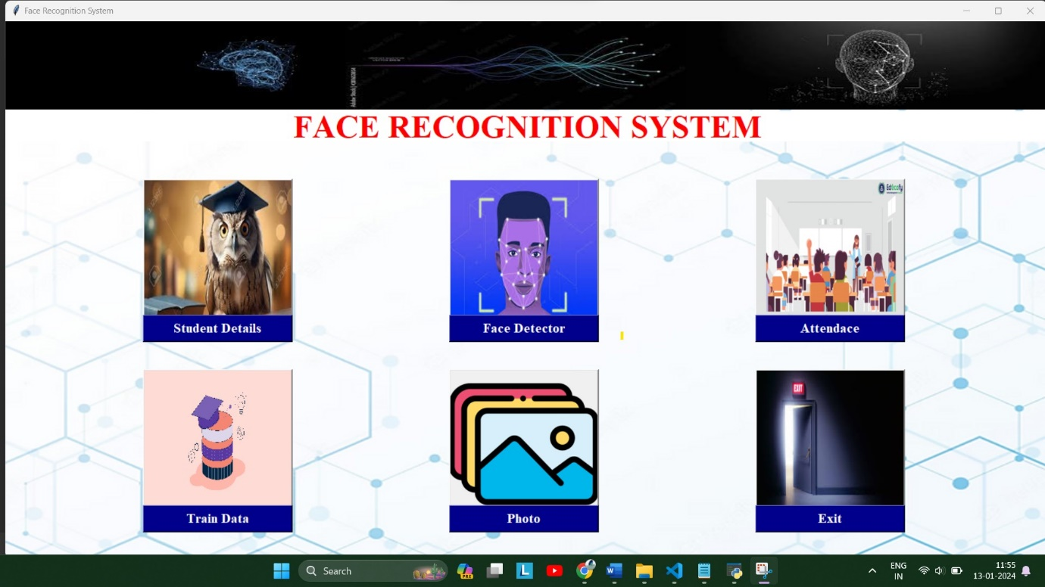

**Step: 2 – Student Details(student.py)**

**­­**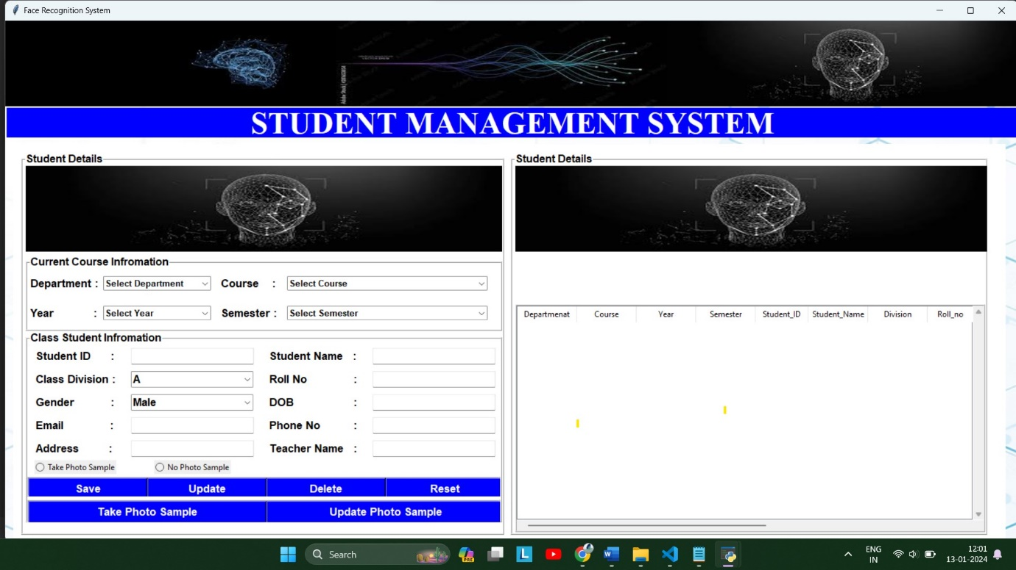

**2.1 Adding Details and Save it**

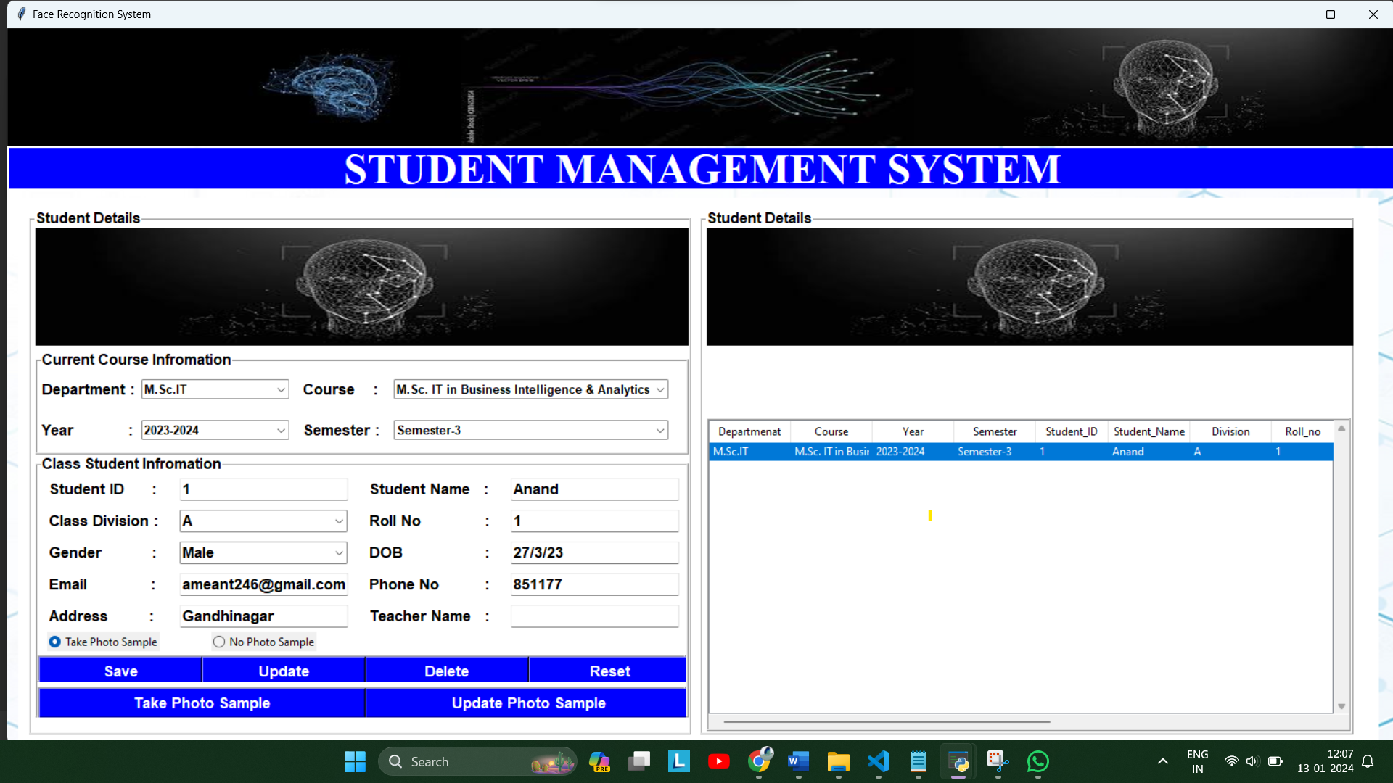

**2.2 Take Photo Sample**

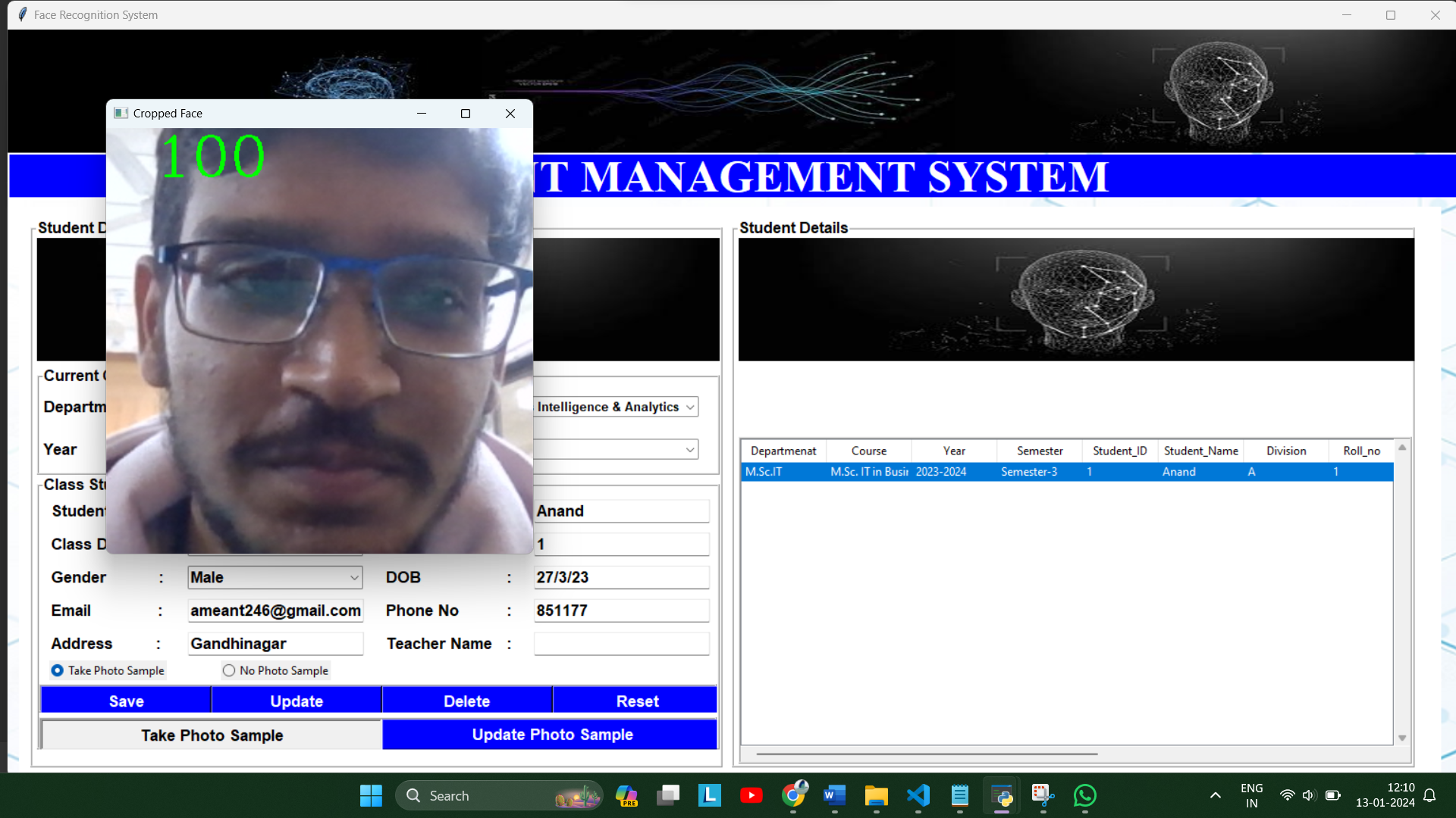

**This Photo Sample Save in Data folder**

**Step – 3 Train Data (train.py)**

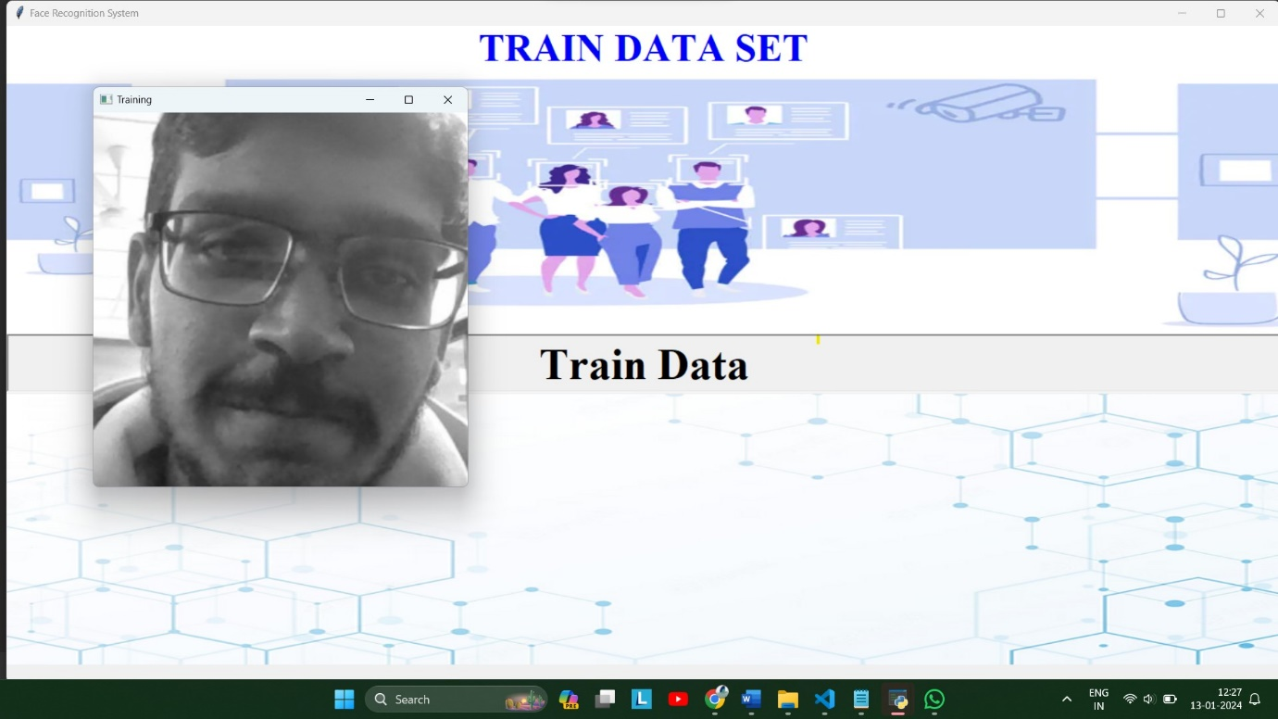

**Step – 4 Face Detector (face_recognition.py)**

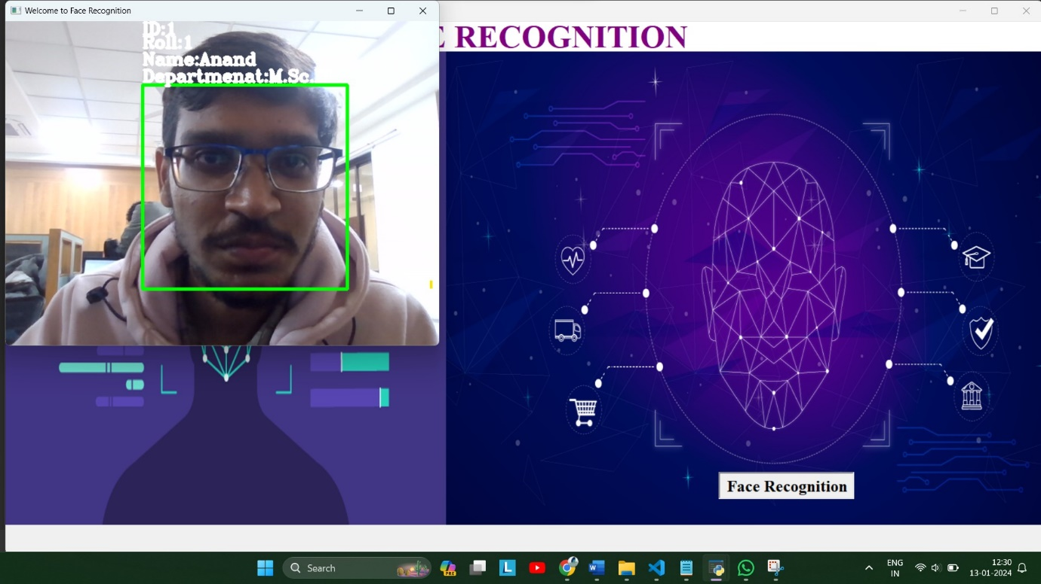

**Step – 5 Attendance (attendance.py)**

* **If Face Detected attendance save in csv file**
* **Where we can import and export csv file**

